Reference-based Representation

What does a Binary Tree node look like?

Using what we know from linked-lists, how can we traverse a tree?
Observation:
root
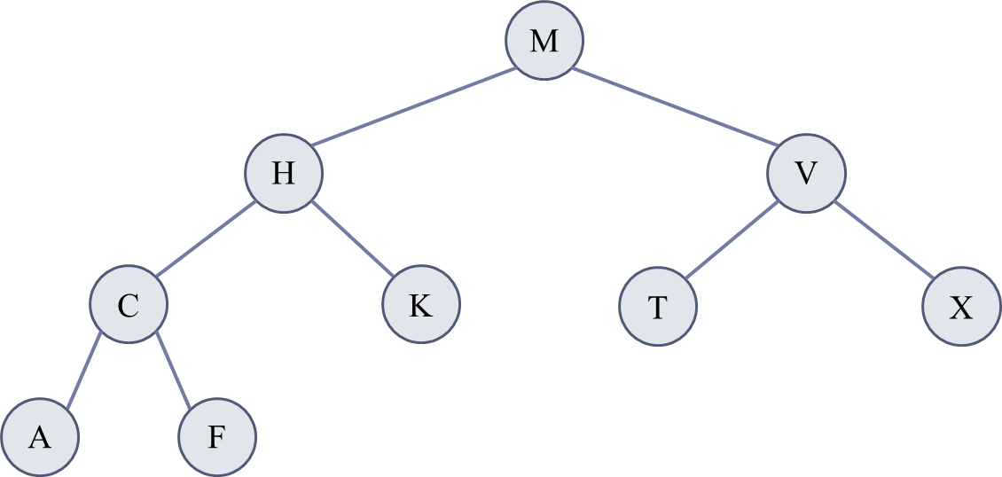

How can we add a node to an existing tree at a certain location?

Array-based representation

What would an array look like representing the same Binary Tree?
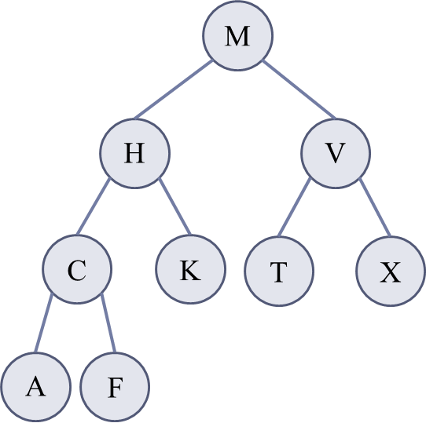

Two methods:
M |  | H |  | V |  | C |  | K |  | T |  | X |  | A |  | F
0 | 1 |  | 2 |  | 3 |  | 4 |  | 5 |  | 6 |  | 7 |  | 8 |  | 9 |  | 10 | 11 |  | 12 |  | 13 |  | 14
- | M |  | H |  | V |  | C |  | K |  | T |  | X |  | A |  | F
0 | 1 |  | 2 |  | 3 |  | 4 |  | 5 |  | 6 |  | 7 |  | 8 |  | 9 |  | 10 | 11 |  | 12 |  | 13 |  | 14
Viewing the tree by the index number of each item:

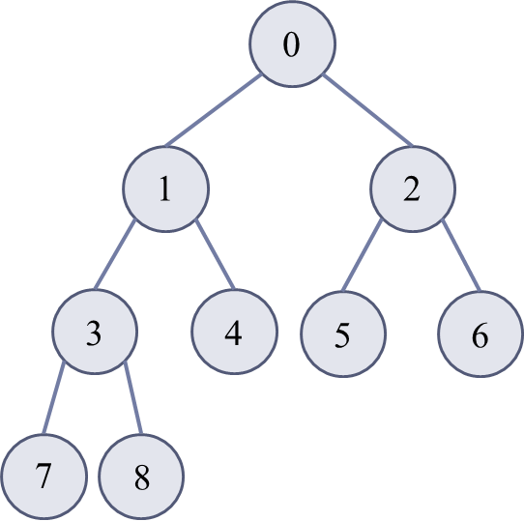
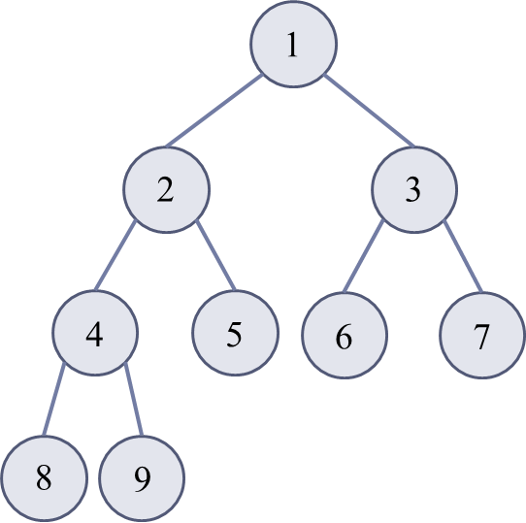

Left child: Left child:
Right child: Right child:
Parent: Parent:

What index would we insert the value U so that it was T’s right child?

Programming Exercise:
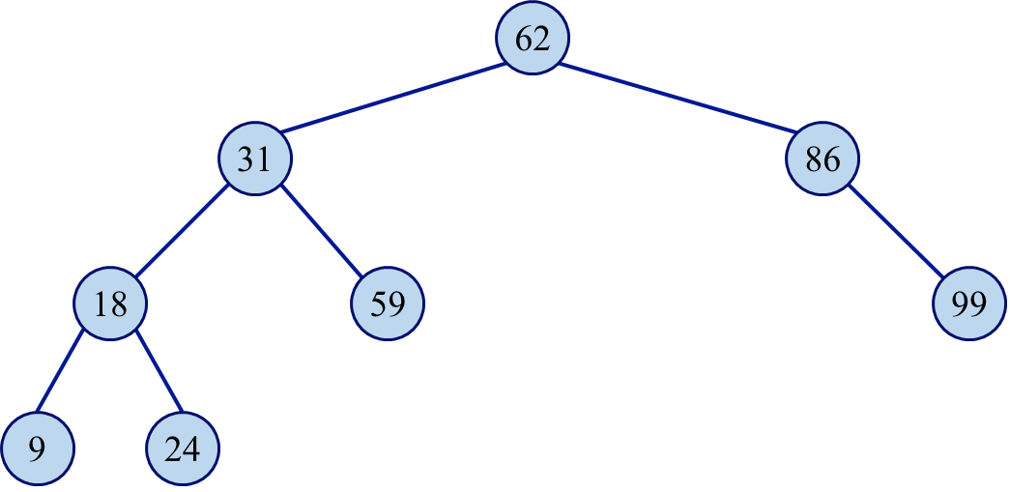
Write a recursive method that, given a node, returns the height of that node. Assume that the height of a tree with just a single root node is 0.

