Tree Traversals:

- In-Order:
- Pre-Order:
- Post-Order:
- Level-Order:
Implementation:
In-Order: | Pre-Order | Post-Order

A different type of traversal: Level-Order

Strategy:

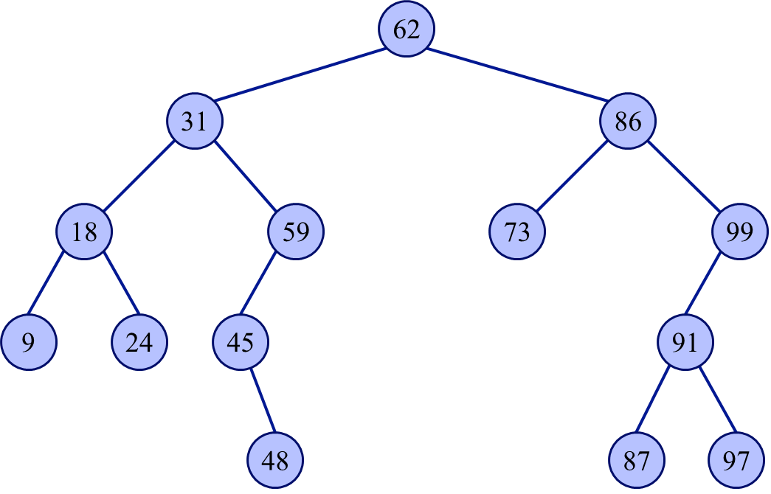

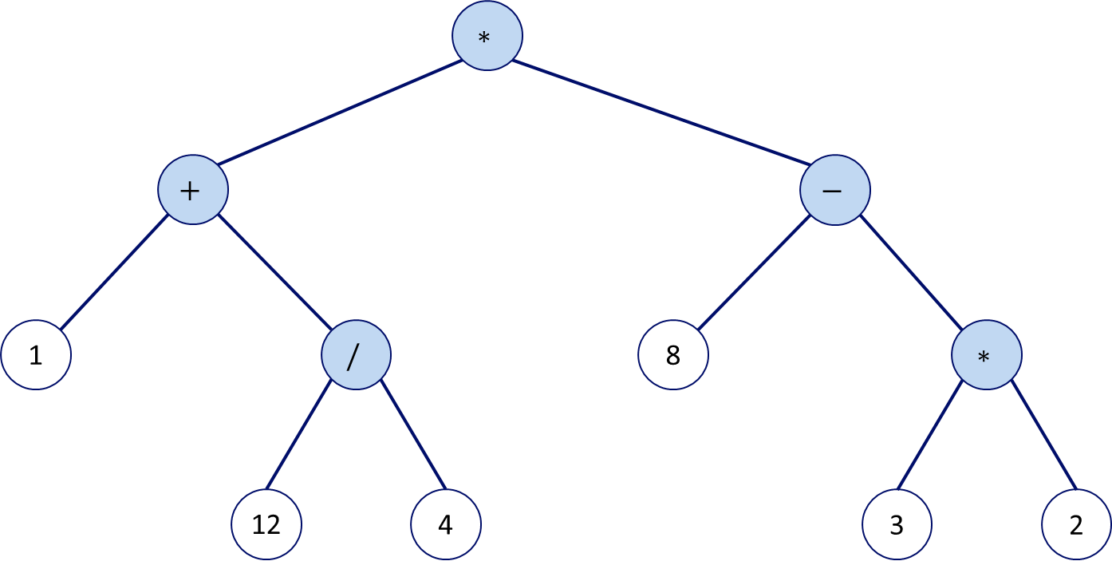
Tree Traversal Application:

Evaluating the expression generated from a Post-Order traversal:

1. Traverse through each item in the post-order expression

2. If item is an operand, push to stack. Otherwise, pop two elements.
- Let A be first popped element
- Let B be second popped element
- Evaluate B <operator> A
- Push result to stack

3. Pop final item and return it.

