Formally, a binary tree T is a minHeap if:

Heap Operation: insert / bubbleUp:
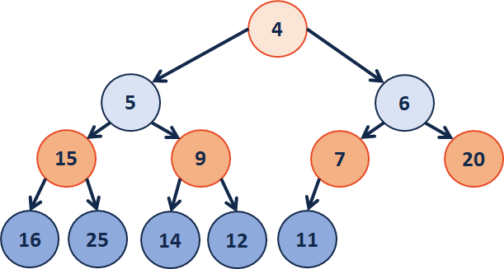

- | 4 | 5 | 6 | 15 | 9 | 7 | 20 | 16 | 25 | 14 | 12 | 11

- | 4 | 5 | 6 | 15 | 9 |  | 20 | 16 | 25 | 14 | 12 | 11

- | 4 | 5 |  | 15 | 9 |  | 20 | 16 | 25 | 14 | 12 | 11

Heap.java (partial)
1  2  3  4  5  6  7  8  9 | void insert(int key) {  // Check to ensure there’s space to insert an element  if (size==CAPACITY) { throw new FullHeapException() }  // Insert the new element at the end of the array  data[++size] = key;  bubbleUp(size); // Restore the heap property  }
31  32  33  34  35  36  37  38 | void bubbleUp( ___________ ) {  if ( __________________ ) {  if ( data[index] < data [ ________ ] ) {  swap(data, index, index/2);  bubbleUp( ____________ );  }  }  }

Heap Operation: removeMin / bubbleDown

- | 4 | 5 | 6 | 15 | 9 | 7 | 20 | 16 | 25 | 14 | 12 | 11

- |  | 5 | 6 | 15 | 9 | 7 | 20 | 16 | 25 | 14 | 12

- |  |  | 6 | 15 | 9 | 7 | 20 | 16 | 25 | 14 | 12

- |  |  | 6 | 15 |  | 7 | 20 | 16 | 25 | 14 | 12

Heap.java (partial)
1  2  3  4  5  6  7  8  9  10 | int removeMin() {  // Swap with the last value  int minValue = data[1];  data[1] = data[size];  data[size] = minValue;  size--;  bubbleDown(1); // Restore the heap property  return minValue; // Return the minimum value  }
1  2  3  4  5  6  7  8  9  10 | void bubbleDown(int index) {  if ( !isLeaf(index) ) {  int minChildIndex = minChild(index);  if ( data[index] _____ data[minChildIndex] ) {  swap(data, index, minChildIndex);  bubbleDown( ___________________ );  }  }  }

