Binary Search Tree Property:
For every node $n$ in the tree:
- All node’s in $n$’s left subtree have keys less than $n$
- All node’s in $n$’s right subtree have keys greater than $n$

Searching for an element in a BST:
root
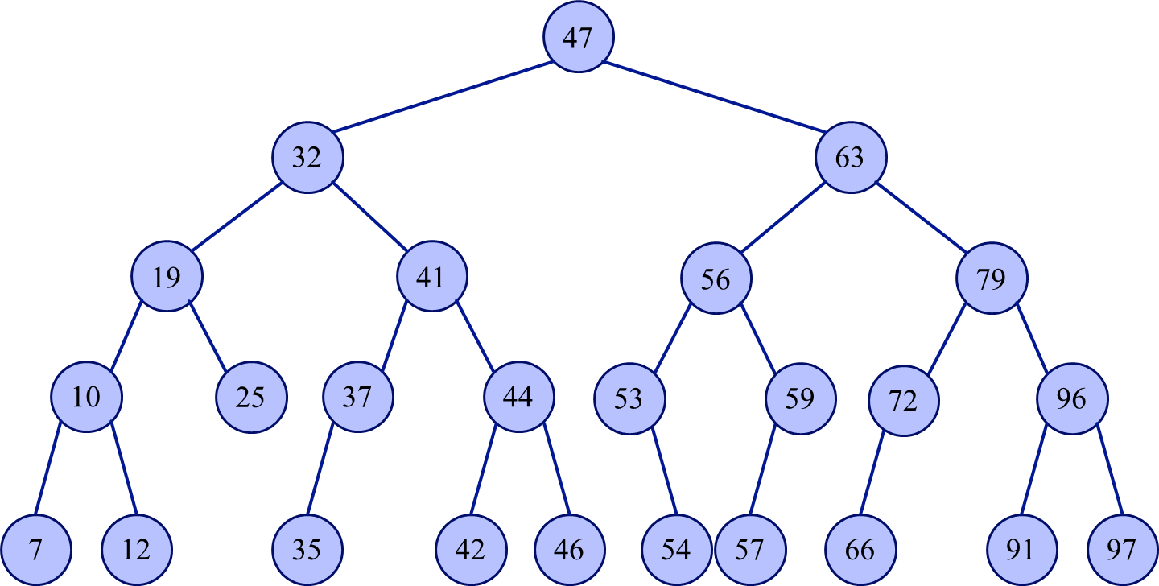

BST.java (partial)
31  32  33 | public TreeNode find(int key) {  return find(root, key);  }
36  37  38  39  40  41  37  38  39  40  41  42  43  44  45  46  47  48  49 | public TreeNode find( TreeNode cur, int key ) {  // if cur is null, key cannot be found  // if we found a node with the correct key, return it  // search the left subtree for the key  // search the right subtree for the key  }
Insertion into a BST:
- Search the tree to identify the position to insert the new node
- Add the new node as a child of the leaf node
Exercise:
- $insert 71$
- $insert 22$

Insert the following elements into an initially empty BST:
$$61, 14, 52, 8, 71, 5, 96, 33, 59$$

Removal from a BST:
- Leaf node:
- Node with one child:
- Node with two children:
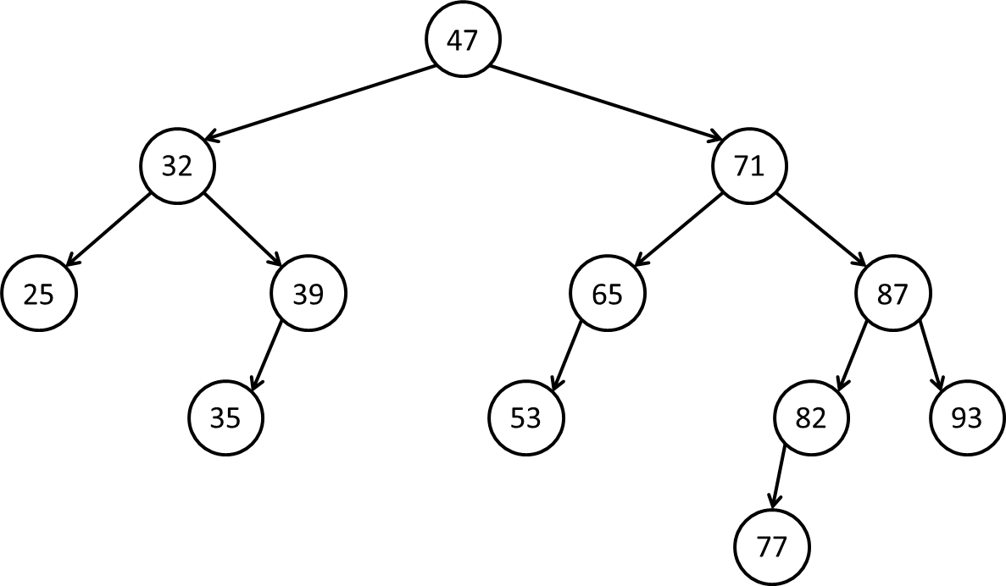
Remove: 25

Remove 82:

Remove 47:

