Hash Tables

Typically, the insertion and find algorithms will attempt to locate a valid location and terminate after $m$ tries.

With linear probing this denotes the fact that every single one of the $m$ locations in the table was examined:
- insertion: this signifies there is no open location to insert into
- find: this signifies no entry matches the target key

Quadratic Probing

Insert the following keys into the initially empty hash table below, with $m=11$. Assume the hash function is $h\left(k\right)=k mod m$

$$43, 25, 14, 91, 07, 33, 58, 17, 03$$

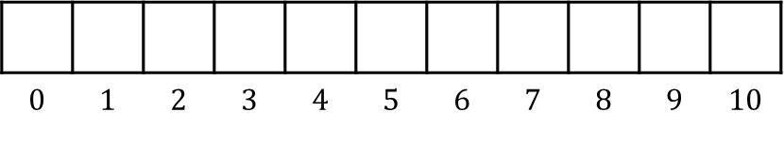

Quadratic Probing Pros and Cons

Pros:

Cons:

Double Hashing

Insert the following keys into the hash table below, The hash function is $h\left(k\right)=k mod m$. The second hash function is $h_{2}\left(k\right)=5-(k mod 5)$

$$43, 25, 14, 91, 07, 33, 58, 17, 03$$

Pros:

Cons:
Deletion in Open Addressing

For this example, examine the table below, with the hash function $h\left(k\right)=k mod 7$, and that uses linear probing:
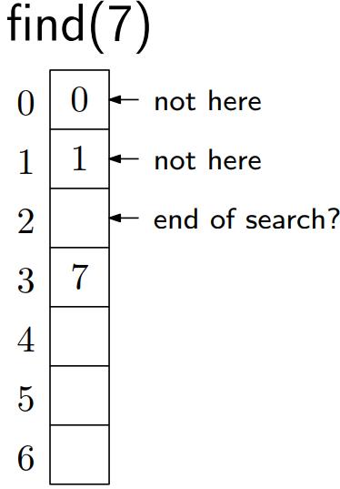
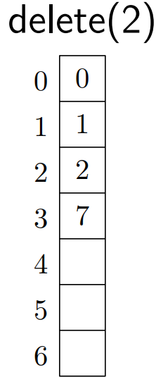

tombstone:

When searching, treat a tombstone as an occupied location.

Questions:

For insertion, can we overwrite the tombstone?

Will the hash table fill up with tombstones?

